Code Execution and displaying Output

Step-1: Create Console application.
Step-2: Copay class file code (image), and paste in Program class file.
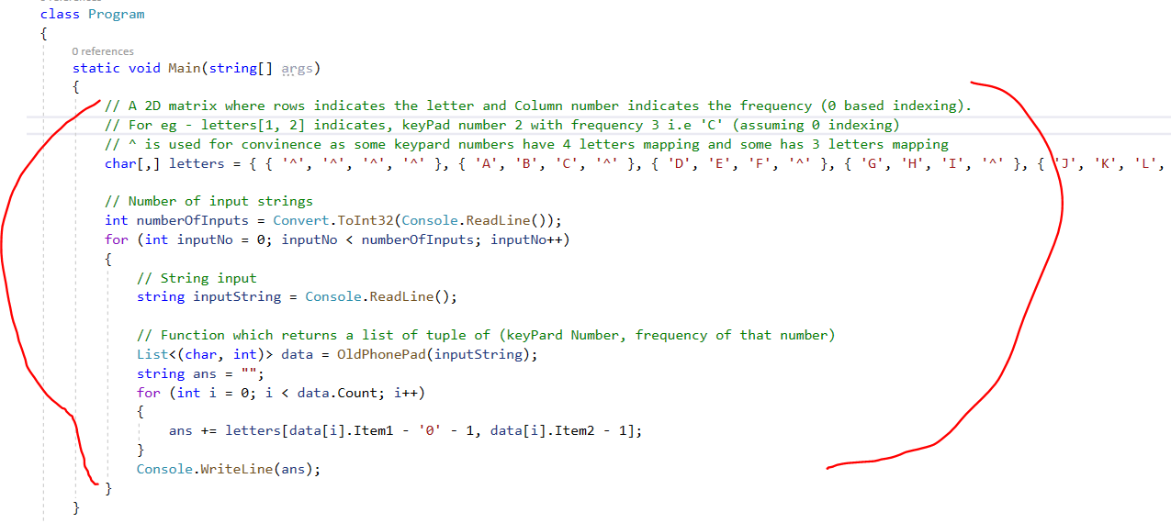
Step-3: Copy OldPhonePad () method and paste in Program class file.
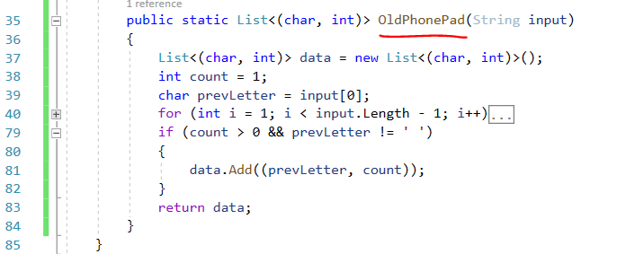

Step-4: Run Console application (F5) and key-in number of entry’s (10).
1st entry: Input value: 2
Output: A
2nd entry: Input value: 22
Output: A
3rd entry: Input value: 222
Output: C
4th entry: Input value: 222 2 22
Output: CAB
5th entry: Input value: 33#
Output: E
6th entry: Input value: 227#
Output: B
7th entry: Input value: 4433555 555666#
Output: HELLO
8th entry: Input value: 8 88777444666*664#
Output: TURNING

